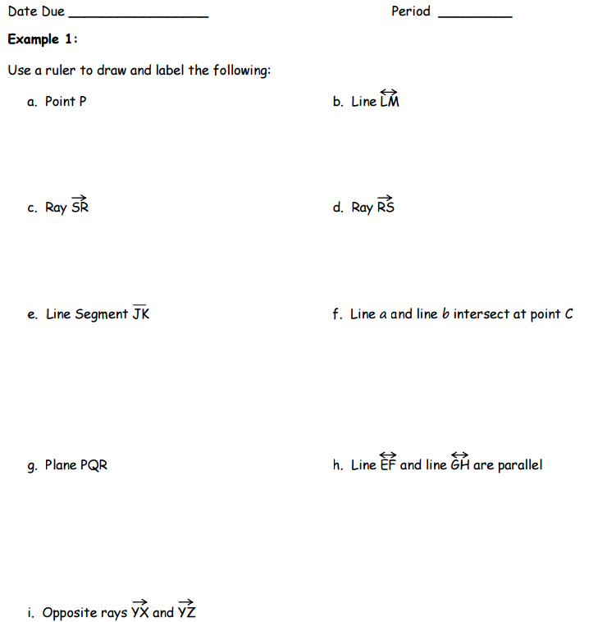

Draw LB contained in Plane M.

Draw RP that lies in Plane XYZ.

Draw MN intersecting Plane P at point N.

Draw 4 noncollinear points that are coplanar in Plane P.

Draw AB interesting CD at point X.

Draw RS, WS and TS intersecting at point S.

Draw Plane ABC intersecting Plane XYZ at CX.

