**1.3 Distance and Midpoint Name__________________________**

Calculate and simplify each of the following:

a) b)  c) d)  e) 

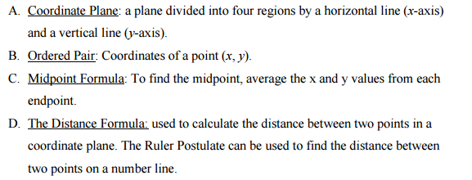

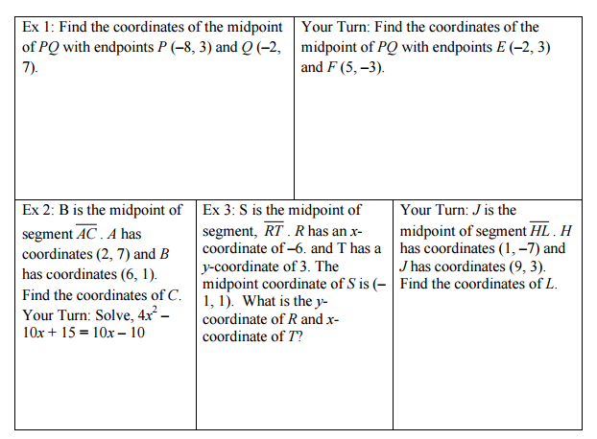

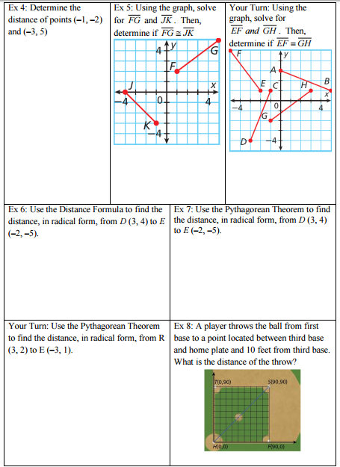

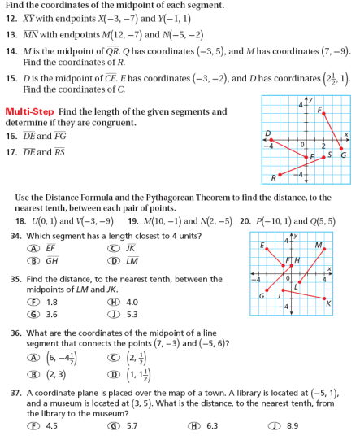

++++++++++++++++++++++++++++++++++++++++++++++++++++++++++++++++++++++++++++++++++

NOW TRY THIS!!! ☺

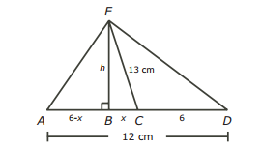Find the area of the triangle.