1.4 Perimeter and Area Name ___________________________
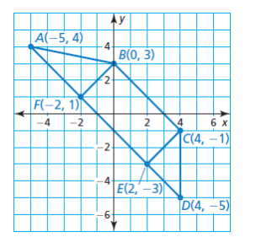
Use the diagram at the right to find each of the following:
- AB

- Perimeter of Triangle CED

- Midpoint of Segment AE

- Area of rectangle BCEF

- FD

- Midpoint of Segment CD

- If C is the midpoint of Segment JE, find the coordinates of point J.

NOTES –
NUMBER OF SIDES | TYPE OF POLYGON
3
4
5
6
7
8
9
10
12
n

Example 1:
Find the perimeter of a square whose area is 40 square cm.

Example 2:
Find the area and perimeter of the right triangle:

