**1.5 Angle Measure NOTES** Name ________________________ Period__________

Bernhard – GT GEOMETRY

What do we know about VERTICAL ANGLES?

Sketch each of the following:

1. Obtuse adjacent angles: 
2. Vertical Angles: 

Angles that form a linear pair are

1. Two angles that form a linear pair.

SKETCH the diagram at the right to answer each of the following:

1. 

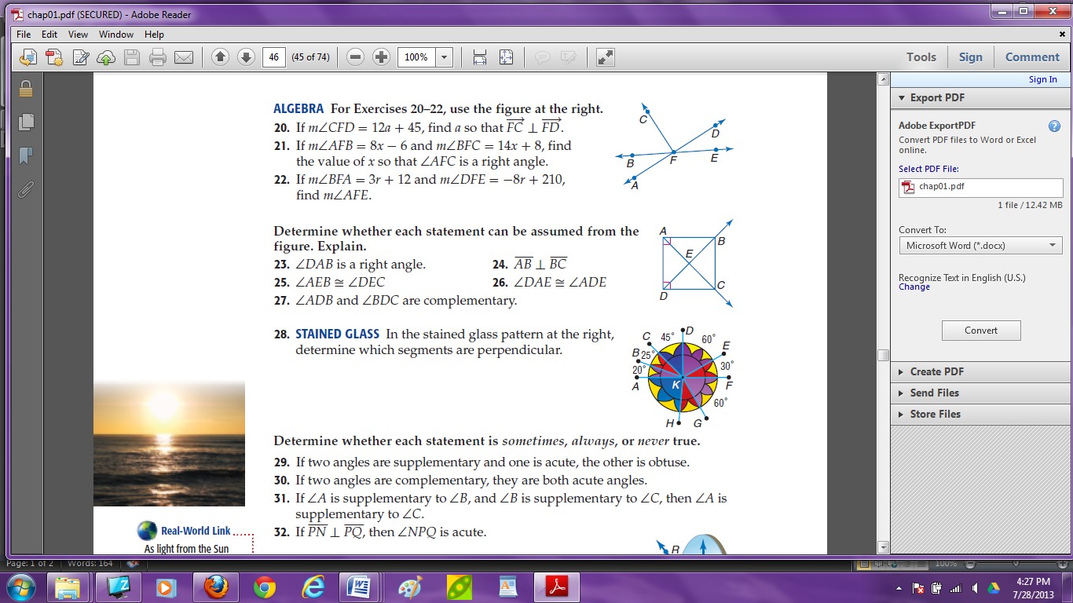

1. What angle is congruent to 
2. 