For #1-3, find the lateral area of each prism or solid. Show all work, including formulas.

ROUND 2 DECIMAL PLACES WHEN NECESSARY!!!

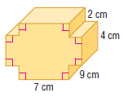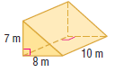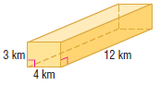1. 2. 3.

3.

4. Find the surface area of a triangular prism with a base that is a right triangle, legs that measure 16 cm and 30 cm, and a height of 14 cm. Draw and label the picture. Show all work, including formulas.

5. The surface area of a cube is 864 in². Find the length of the lateral edge of the cube.

For #6-7, find the surface area of each prism. Show all work, including formulas. Round to the nearest tenth if necessary.
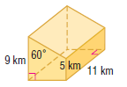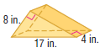
6. 7.

9. The surface area of a triangular prism is 540 cm². The bases are right triangles with legs measuring 12 cm and 5 cm. Find the height.

For #10-11, find the volume of each prism or cylinder. Round to the nearest tenth if necessary.
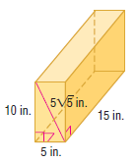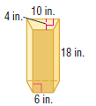
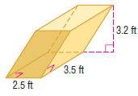10. 11. 12.

The volume of a rectangular prism is 1152 in³, and the area of the base is 64 in².
Find the length of the lateral edge of the prism. Show all work, including formulas.

14. Find the volume of the solid formed by the net. Show all work.

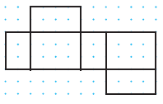

15. Find the volume of the composite solid. Show all work, including formulas. Round to the nearest tenth if necessary.

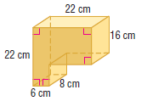

16. Che and Julia are trying to find the volume of the oblique prism.
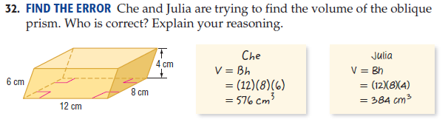Who is correct? Explain your reasoning.

