GT GEOMETRY BERNHARD Name _____________________________



Topics from 4.7-5.3 Period 2nd 3rd 4th Date ____________

SHOW ALL WORK FOR CREDIT!!

1. Name the missing coordinates of each triangle:



2. Solve for each variable in the problems using the given information.

a)  is a median of .  and .

b)  is an angle bisector of . is a right angle, 

c) In are medians intersecting at point M. 

d) In  Find each angle measure and then list the sides in order from LEAST to GREATEST.

3. Short answer:

a) An architect is designing a high school building. Where should she position the central office so it is equidistant from each of the three school entrances?

b) What is the best name for the point of intersection of the three medians in a triangle?



4. Given: 







STATEMENTS REASONS

1. 1.

2.  2.

3.  3.

4.  4.

5.  5.

6.  6.

7. 7.

5. Place a check mark where appropriate.

|  |  |  |  |  |
| --- | --- | --- | --- | --- |
|  | INCENTER | CIRCUMCENTER | CENTROID | ORTHOCENTER |
| Is the intersection of the angle bisectors of the triangle |  |  |  |  |
| Is the center of mass of the triangle |  |  |  |  |
| Can be located outside the triangle |  |  |  |  |
| Is equidistant from the vertices of the triangle |  |  |  |  |
| Is the intersection of the perpendicular bisectors of the triangle |  |  |  |  |
| Is located at the right angle of a right triangle |  |  |  |  |

6. Determine the relationship between the measures of the given angles:

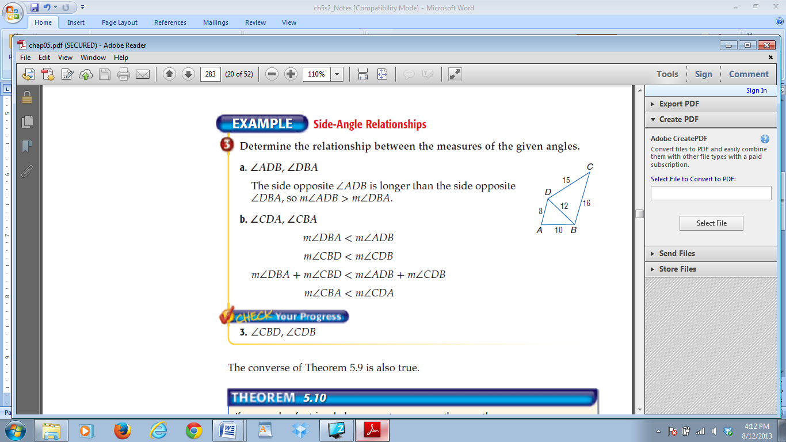a. ∠ADB, ∠DBA

b. ∠CDA, ∠CBA

c. ∠CBD, ∠CDB

7. Determine which angle has the greatest measure

a. ∠1, ∠2, ∠4

b. ∠2, ∠3, ∠5

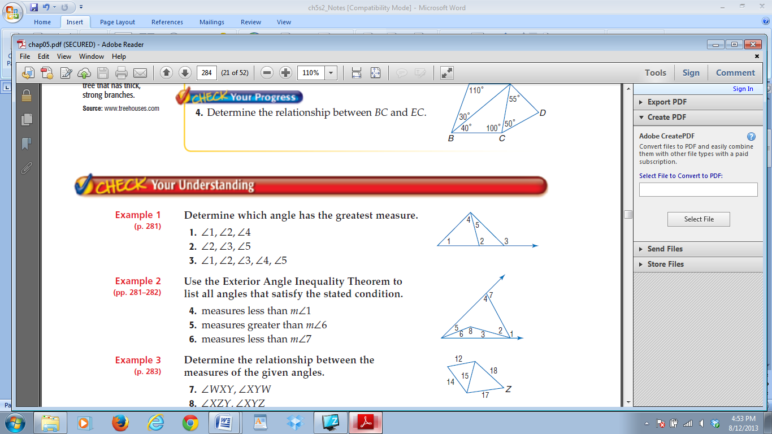c. ∠1, ∠2, ∠3, ∠4, ∠5