**Shaded & Composite Regions**

Worksheet

For #1-6, find the area of the shaded regions. Show all work. Leave answers exact.

20 ft

17 ft

8 ft

1.

Area = _____________

2.

10 in

Area = _____________

3.

3 in

13 in

4 in

8 in

Area = _____________

4.

22 m

Area = _____________

5.

20 m

16 m

18 m

Area = _____________

6.

30 in

Area = _____________

For #7-10, find the area of the shaded regions. Point C is the center of the circle. Leave answers exact. Show all work. All polygons are regular figures.

7.

8 in

Area = _____________

8.

24 cm

Area = _____________

9.

C

8m

Area = _____________

10.

12 m

C

Area = _____________

11. Find the area of the sector.

6

.

60

Area = __________

12. A circle has an area of 160 cm2. If a sector of the circle has an area of 40 cm2, find the

measure of the arc of the sector.

13. The area of sector AOB is 10 and mAOB = 100. Find the radius of circle *O*.

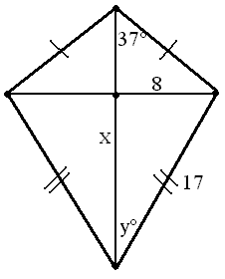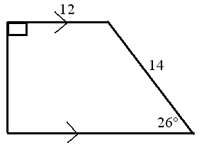

14. 15.

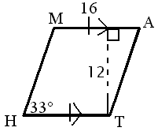

**MH** = _____ **Area** = _____ **Height = _____ Area = _____**

**x** **=** ________ **y˚** **=** _______  **Area = ________**