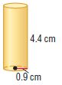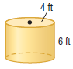1. SA = ____________ 2. SA = ____________

3. Find the radius of the base of a cylinder with a surface area of 48 cm² and a height of 5 cm.

4. Find the diameter of the base of a cylinder with a surface area of 320 m² and a height of 12 m.

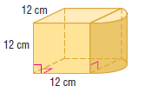
5. Find the surface area of the composite solid. SA = ____________

6. Isabel has a swimming pool that is shaped like a cylinder. She wants to get a plastic sheet to keep the side of the pool from getting scratched. What is the area of the sheet?

Area = ____________

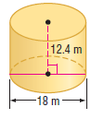7. Find the volume of each cylinder.
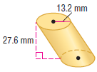
Volume = ____________ Volume = ____________

8. The volume of a cylinder is 615.8 m³, and the height is 4 m. Find the length of the diameter of the cylinder.

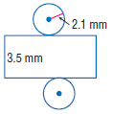

9. Find the volume of the solid formed by the net.

Volume = ____________

1. A can 12 cm tall fits in to a rubberized cylindrical holder that is 11.5 cm tall, including 1 cm which is the thickness of the base of the holder. The thickness of the rim of the holder is 1 cm. What is the volume of the rubberized material that makes up the holder?

Volume = ____________

2. A 40-story building is a rectangular prism with a length of 300 ft and a width of 220 ft. On top of the rectangular prism is a triangular prism, the base of which has a height of 150 ft and a base of 220 ft. If each story is 11 ft, find the volume of the building.
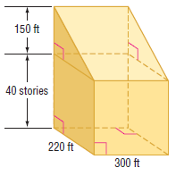 Volume = ____________

