For each problem, show all work, including formulas, and round two decimal places unless otherwise specified. Include units.

For #1-4, find the surface area of each regular pyramid.

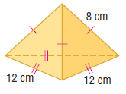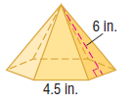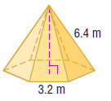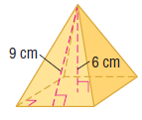1. SA = _______ 2. SA = ________ 3. SA = _________ 4. SA = ____________

5. The roof on a building is a square pyramid with no base. If the altitude of the pyramid measures 5 ft and the slant height measures 20 ft, find the area of the roof. Draw and label the roof.

Area = ____________

6. A "frustrum" is the part of a solid that remains after the top portion has been cut by a plane parallel to the base. Find the lateral area of the frustrum of a regular pyramid

LSA = ____________

7. Find the volume of the pyramid.

a)Volume = ____________ b) Volume = ____________
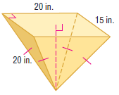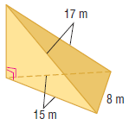

c) Volume = ____________ d) Volume = _____________
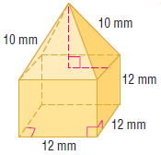

Volume = ____________

e) Volume = ____________ f) Volume = ____________

8. The start of the pyramid age began with King Zoser’s pyramid, erected in the 27th century B.C. In its original state, it stood 62 meters high with a rectangular base that measured 140 meters by 118 meters. Find the volume of the original pyramid. Draw and label the pyramid.

Volume = ____________

9. Find the surface area of the regular pyramid.
SA = ____________

#7-9, use the following information. A stage has the form of a square pyramid with the top sliced off along a plane parallel to the base. The side length of the top square is 12 feet and the side length of the bottom square is 16 feet. The height of the stage is 3 feet.

7. What is the volume of the entire square pyramid that the stage is part of?

Volume = ____________

8. What is the volume of the top of the pyramid that is removed to get the stage?

Volume = ____________

9. What is the volume of the stage?

Volume = ____________

