Show all work, including formulas, and round to 2 decimal places unless otherwise specified. Include units.

For #1-3, find the surface area of each cone.

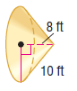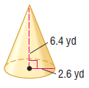1. SA = __________ 2. SA = __________ 3. SA = __________
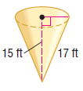

4.. Find the surface area of a cone if the height is 8.7 meters and the slant height is 19.1 meters.

SA = __________

5. The surface area of a cone is 293.2 ft² and the radius is 6.1 ft. Find the slant height of the cone.

Slant Height = __________

6. A spotlight is positioned directly above a performer. If the lateral area of the cone of light is approximately 500 ft² and the slant height is 20 ft, find the diameter of light on stage.

Diameter = __________

7. A conical tent is being assembled for a festival. If the radius of the base is 6.1 ft and the slant height is 15 ft, what is the lateral surface area of the cone?

LSA = __________

For #8-10, find the volume of each cone.
8. Volume = __________ 9. Volume = __________ 10. Volume = __________
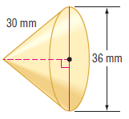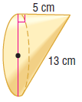
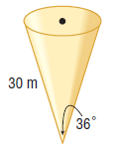

11. Potting soil is sold in 3 cubic feet bags.
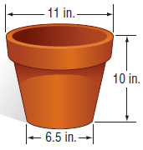 a) What volume of soil will fill one planter?

Volume = __________

b) How many planters could be filled with one bag of potting soil?

Number of Planters = __________

12. Compare the volumes of the cylinder, cone and pyramid. Determine which volume is the greatest.
Volume_{Cylinder} = __________

Volume_{Cone} = __________

Volume_{Pyramid} = __________

Solid with the Greatest Volume :_________________

13. The Great Pyramid of Khufu is a square pyramid. The lengths of the sides of the base are 755 feet. The original height was 481 feet. The current height is 449 feet. What volume of material has been lost?

Volume_{Original} = _______________

Volume_{Current} = _______________

Volume_{Lost} = _______________
14. What is the probability of choosing a point inside the cylinder, but not inside the cone that has the same base and height as the cylinder?

Probability = __________

