CONSTRUCTIONS Name____________________
- Use pencil, compass and straightedge!
- Show all markings!

- Use the following line segment.

- Construct a copy.

b. Find its midpoint. (Use your construction from part A.)
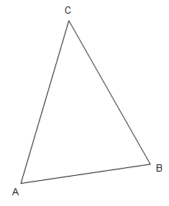
- Use the line segment AB from the triangle.

- Construct a copy of AB.

- Bisect the new segment.

- Use the following angle.

- Construct a copy of the angle.

- Bisect the new angle.
- Use the following triangle.
a) Construct a copy of Angle A.

- Bisect angle B on the original triangle.

- Bisect each angle.

- Copy the following segment and find it midpoint.

- Copy the following angle and find the angle bisector on the copy.

