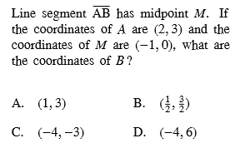
DISTANCE and MIDPOINT Practice Name ____________________
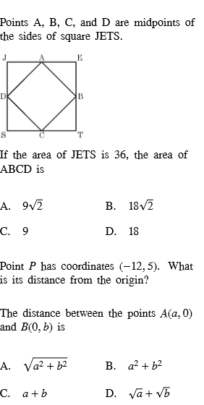
Bernhard – GT GEOMETRY

