Geometry Proofs #1 Name _____________________ Period ____________

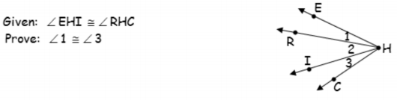1.

Statements Reasons

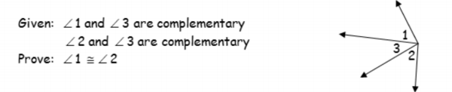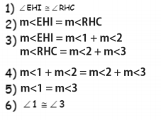

2.

Statements Reasons

1)

2)

3) 

4)

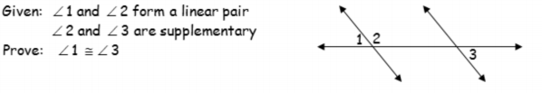5)

3.

Statements Reasons

1) 1)

2) 2)

3)  3)

4) 4)

5) 5)