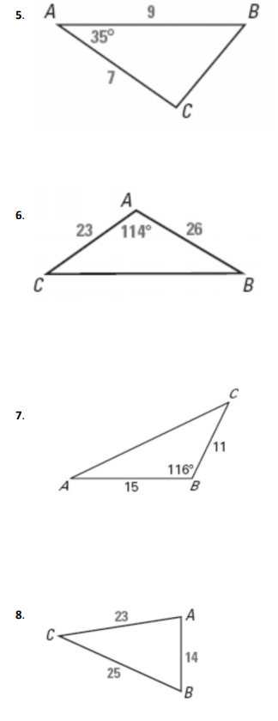OTHER TRIANGLE AREA FORMULAS

HERON’s FORMULA

A triangle has side lengths a, b and c.

s = the semiperimeter (the perimeter divided by 2)

The area is given by



SINE FORMULA:

A

B c

C

a

B



