INDIRECT PROOFS Name __________________ 2nd 3rd 4th

BERNHARD – GT GEOMETRY Due by the end of class 11/3

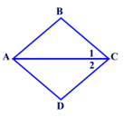1.



2. Given: 

3. GIVEN: 

PROVE: 