**Inequalities in Triangles – GT Geometry**  Name __________________________

Bernhard

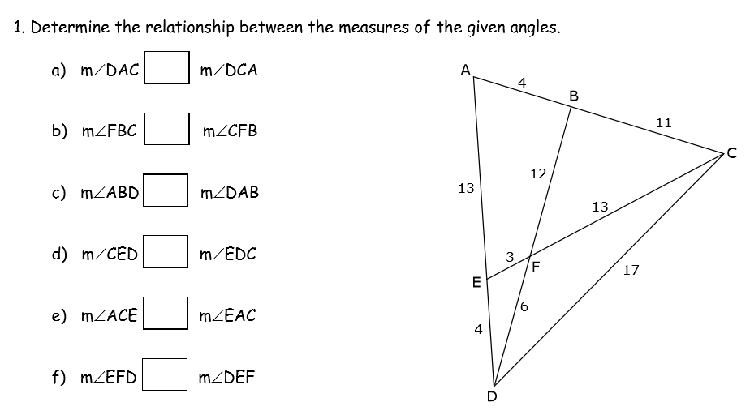

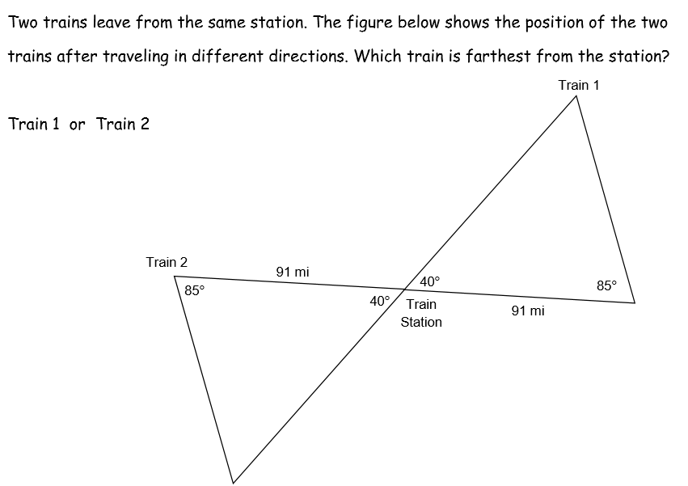2.

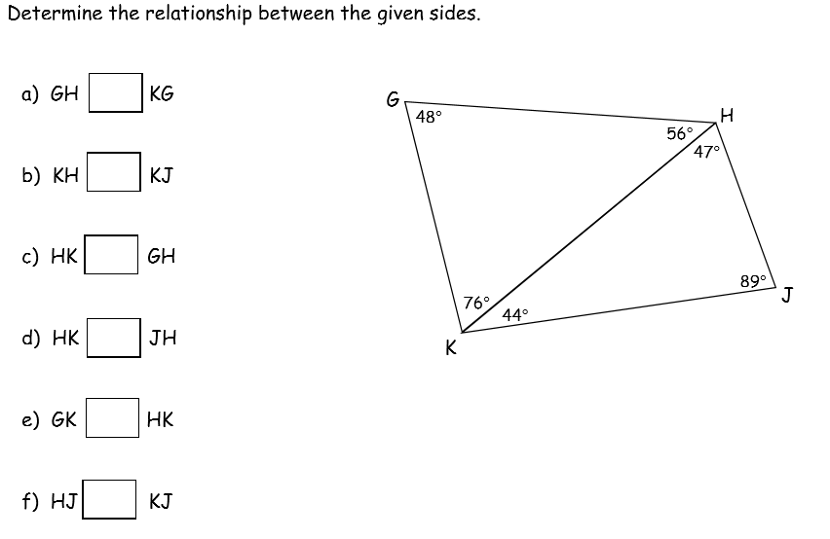3.

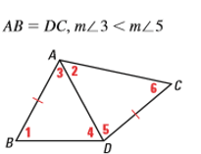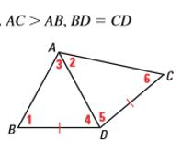

4. 5.

