More Polygon & Parallelogram Practice Name _______________________
Bernhard – GT GEOMETRY
1.
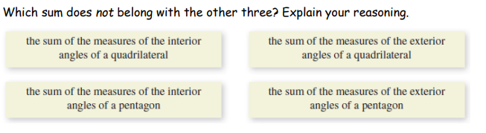
2. 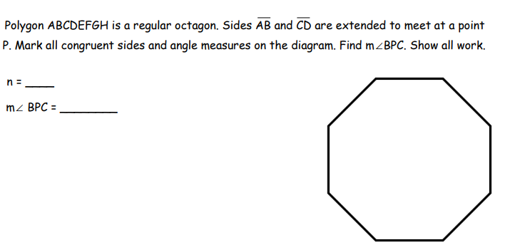
3. Find the value of each variable for each parallelogram.

