**POINTS OF CONCURRENCY CHART**

|  |  |  |  |  |  |  |  |
| --- | --- | --- | --- | --- | --- | --- | --- |
|  | **Name of**  **Special Segment**  **of Triangle** | **Point of**  **Concurrency** | **Property**  **of Point**  **of Concurrency** | **Relation to a Circle** | **Where does the point lie?**  **Inside, Outside or On the Triangle?** | | |
| **Special Type of Triangle** | | |
| **Acute** | **Obtuse** | **Right** |
| circumcenter and circumcircle | Perpendicular  Bisector | Circumcenter | Equidistant from the vertices of the triangle | Center of the circumscribed circle | Inside | Outside | On  (at the midpoint of the hypotenuse) |
| incenter and incircle | Angle  Bisector | Incenter | Equidistant from each side of the triangle | Center of the inscribed circle | Inside | Inside | Inside |
| centroid | Median | Centroid | The distance from a vertex to the centroid is two-thirds of the median.  The distance from a midpoint to the centroid is one-third of the median. | Center of gravity | Inside | Inside | Inside |
| othocenter | Altitude | Orthocenter | The distance from the orthocenter to a vertex is twice the distance from the circumcenter to the opposite side | None | Inside | Outside | On  (At the vertex of the right angle) |

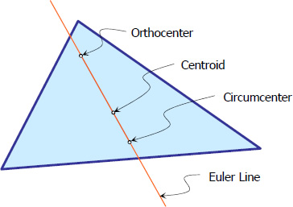**Euler Line** - line that would pass through

the orthocenter, circumcenter, and centroid

of the triangle

