GT Geometry – K. Bernhard Name _______________________Date________________

Don’t forget to SIMPLIFY! ☺

Practice 1.1-1.3

USE PENCIL!! SHOW ALL WORK FOR CREDIT!! No decimals or mixed numbers please ☺

FILL IN THE BLANK:

__________________________was a [Greek mathematician](https://en.wikipedia.org/wiki/Greek_mathematics), often referred to as the "Father of Geometry." His book [*Elements*](https://en.wikipedia.org/wiki/Euclid%27s_Elements) is one of the most influential works in the [history of mathematics](https://en.wikipedia.org/wiki/History_of_mathematics), serving as the main textbook for teaching [mathematics](https://en.wikipedia.org/wiki/Mathematics) (especially [geometry](https://en.wikipedia.org/wiki/Geometry)) from the time of its publication until the late 19th or early 20th century. He deduced the principles of what is now called ___________________from a small set of [axioms](https://en.wikipedia.org/wiki/Axiom). He also wrote works on [perspective](https://en.wikipedia.org/wiki/Perspective_(visual)), [conic sections](https://en.wikipedia.org/wiki/Conic_section), [spherical geometry](https://en.wikipedia.org/wiki/Spherical_geometry), [number theory](https://en.wikipedia.org/wiki/Number_theory) and [rigor](https://en.wikipedia.org/wiki/Mathematical_rigour).

President _________________________kept a copy of [*Elements*](https://en.wikipedia.org/wiki/Euclid%27s_Elements) in his saddlebag, and studied it late at night by lamplight; he related that he said to himself, "You never can make a lawyer if you do not understand what demonstrate means.”

President _______________________ was a mathematician who displayed his talent by developing a trapezoid proof of the Pythagorean Theorem.

1. Find the value of each variable if S is between R and T.

a) 

Please sketch and label!!!

b) 

c) 

2. Find the value of each variable. a) 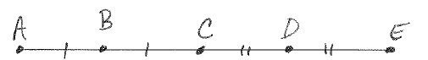

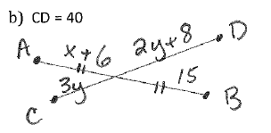

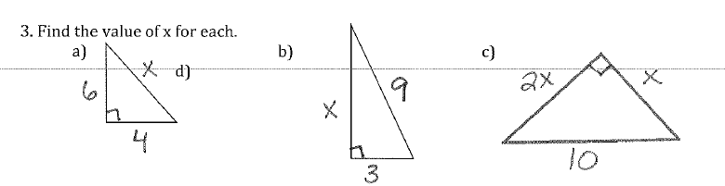

4. Given each set of points, calculate PQ **AND** the midpoint of segment PQ.

1. 
2. 

5. Answer each of the following statements with AT (always true), ST (sometimes true) or NT (never true).

________ a) Two points are collinear.

________ b) Three points are collinear.

________ c) Two coplanar lines intersect.

________ d) A line and a point are coplanar.

________ e) Two lines are coplanar.

6. Find the coordinate of point R, given that S is the midpoint of segment RT. 

50