Name Date Period
Prisms, Cylinders, Cones and Pyramids Worksheet

In exercises 1 – 3, find the area of a base of the prism or cylinder.

1) Right rectangular prism 2) Oblique rectangular prism 3) Right circular cylinder
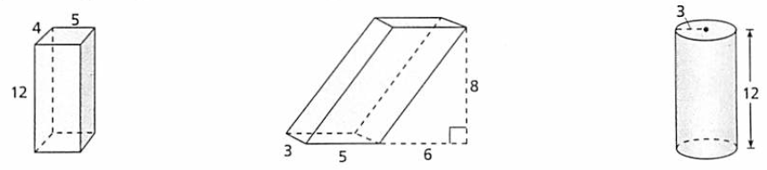

In exercises 4 – 7, find the lateral area of the regular pyramid or right cone. Round your result to the thousandths place.
4) 5) 6) 7)

In exercises 8 – 11, find the surface area of the right prism or right cylinder. Round your answers to the thousandths place.
8) 9) 10) 11)

In exercises 12 – 14, find the surface area of the solid. Remember to include the area of both lateral surfaces. Round your results to the thousandths place.
12) 13) 14)

In exercises 15 – 17, find the surface area of the rectangular oblique prism. Explain your reasoning.
15) 16) 17)

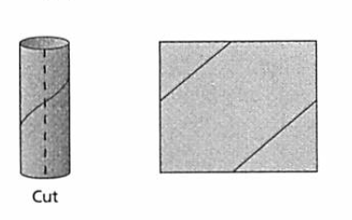
18) The cardboard tube in a roll of paper towels has a diameter of 1.7 inches and a height of 11 inches.
If the tube were cut and unfolded to form a rectangle, what would the rectangle’s area be?

In exercises 19 – 22, find the surfacee area of the solid. The pyramids are regular, and the prisms, cvylinders, and cones are right. Round your result to the thousdandths place.
19) 20) 21) 22)

In exercises 23 – 26, each regular pyramid is inscribed in a right cone whose radius is 1 unit and whose slant height is $\sqrt{\text{2}}$ units. Match the pyramid with its surface area without actually calculating the surface area. Explain your reasoning.

a) 7.32 square units b) 5.46 square units c) 6.56 square units d) 7.00 square units

23) Square 24) Hexagon 25) Octagon 26) 12 - gon

In exercises 27 – 30, draw the pyramid or cone that can be folded from the net. Then find its surface area.
27) 28)

29) 30)

