**CHAPTER 2 TEST REVIEW Name ___________________ Period ________**

**GT GEOMETRY – Bernhard**

1.Make a conjecture about the next term in each sequence:

_________a) 1,1,2,3,5,8,….. ___________ c) -11, 22, -44, 88,…..

_________b) 1/5, 1, 25, 125,….. ___________ d) 1, 8, 27, 64, 125,……

2.Find the nth term of the following sequences:

_________a) -1,1,3,5,7,….. ___________ c) -11, -15, -19, -23,…..

_________b) 1/5, 6/5, 11/5, 16/5,….. ___________ d) 1/3, 2/3, 1, 4/3……

3.Determine whether the following statements represents a valid deductive argument.

Write VALID or INVALID. (Do the first 2 statements imply the third?....)

A) Vertical angles are congruent.

Angle ABC and Angle DBE are vertical angles.

Angle ABC and Angle DBE are congruent.

B) All students in Lovejoy take a math class.

Jack takes a math class.

Jack is a Lovejoy student.

C) If I get suspended, I can’t go Six Flags.

I went to Six Flags.

I did not get suspended.

In geometry, REGULAR means it is both EQUILATERAL and EQUIANGULAR.

D) All students in Lovejoy take a math class.

Reagan is a Lovejoy student.

Reagan takes a math class.

4. Rewrite the statement as a biconditional:

If a quadrilateral is regular, then it is a square.

5.What can you conclude by using the given statement together with each conditional statement? If no conclusion is possible, write NONE.

GIVEN: All geometry students love doing proofs.

1. Carson loves doing proofs.
2. Chase is a geometry student.
3. Marcie does not love doing proofs.
4. Brooke is not a geometry student.

|  |
| --- |
| 6. Determine which property, postulate, theorem or definition is being demonstrated.  __________ 1. If Angle X and Angle Y are complementary angles, then the sum of their measures is 90 degrees.  __________ 2. If x = 7, then x/8 = 7/8.  __________ 3. If , then is a right angle  __________4. If B is the interior of Angle ACD, then m<ACB+m<BCD=m<ACD.  __________ 5. If Segment AB is congruent to Segment MN, then AB=MN.  __________ 6. If Ray JK bisects segment PQ at point M, then PM=QM.  __________ 7. If m<8=90 degrees and m<8+m<1=100 degrees, then 90 degrees + m<1 = 100 degrees.  __________8. If x+7 = 9, then x+6=8.  __________9. If m<3=x, then x=m<3.  __________10. If AB=CD and CD=EF, then AB=EF.  7. Complete the each proof:  Given: $\frac{2(x+6)}{3}+4=16$ Prove: x=12  **STATEMENTS REASONS**      **STATEMENTS REASONS** 1) 1)  2) 2) Definition of a Right Angle  3)  3)  Step 5 uses Steps 2,3, and 4.  4)  4)  5)  5)  6) 6) Subtraction POE  7) 7) |
| **STATEMENTS REASONS** |
|  |
| 8. Determine whether each uses INDUCTIVE or DEDUCTIVE reasoning.  a) Tampa Bay has lost their last 3 games. Thus, they will probably lose their next game.  b) All dogs are mammals. All mammals have kidney. Therefore, all dogs have kidneys.  c) Even numbers are divisible by 2. 28 is an even number. 28 is divisible by 2.  d) A child examines ten tulips, all of which are red, and concludes that all tulips must be red. |

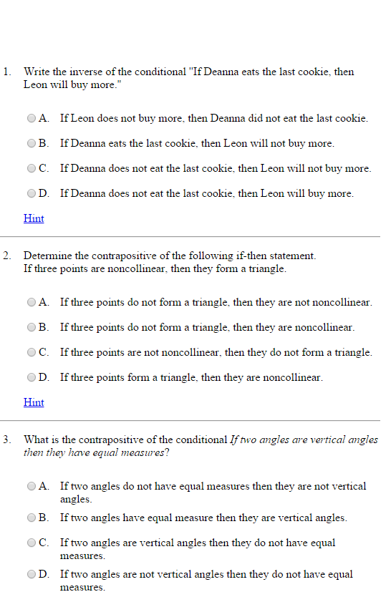

Be sure you know:

CONDITIONAL

CONVERSE

INVERSE

CONTRAPOSITIVE

BICONDITIONAL