Proofs with triangles



1. Given: M is the midpoint of 



****Prove: 

*D*

*A*

*E*

*R*

*H*

1. Given: 





Prove: 

1. Given: 

*Y*

*X*

*T\T*

*Z*

*V*



Prove: 

*C*

*B*

*D*

*N*

*E*

*A*

*1*

*2*

1. Given: N is the midpoint of 





Prove: 

1. Given:  bisects 

*A*

*N*

*S*

*E*

*Y*





Prove: 

*A*

*I*

*C*

*B*

1. Given: bisects



Prove: 

SHOW ALL MARKINGS!!

1. Determine which theorem/postulate can be used to prove that the triangles are congruent.

If it is not possible to prove that they are congruent, write *not possible.*

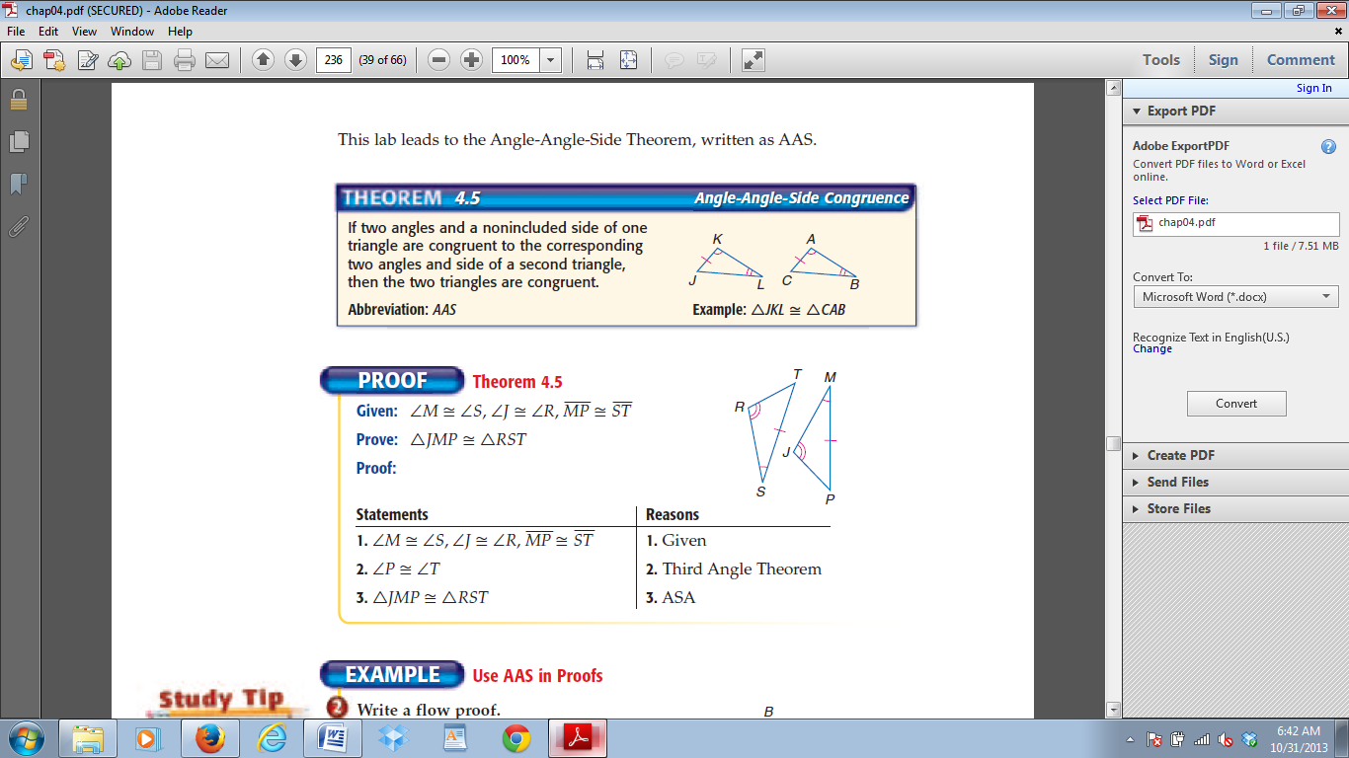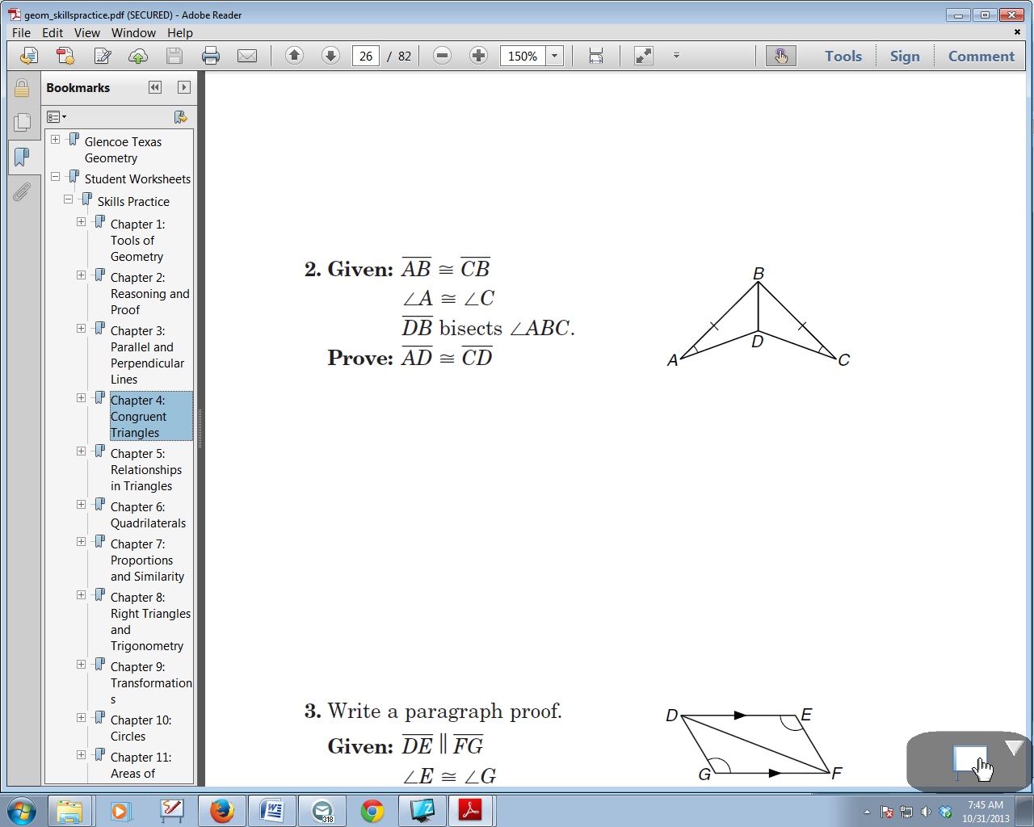a. ______________ b. ______________ c. ______________

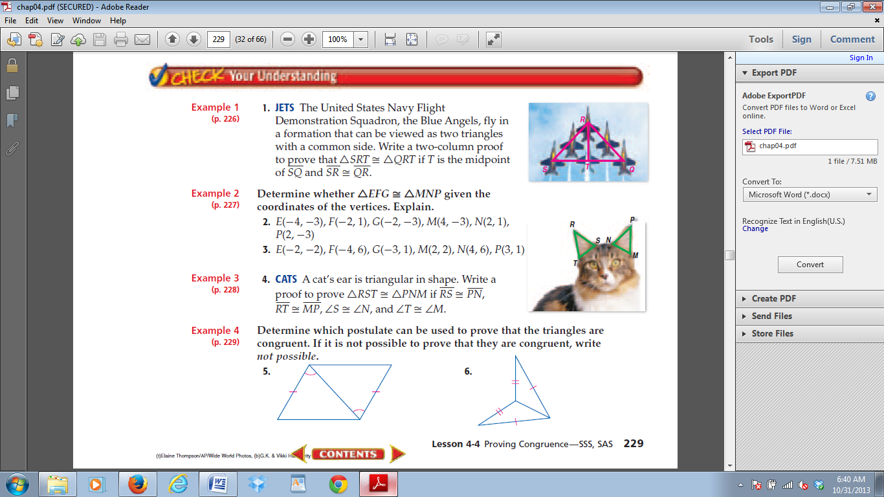

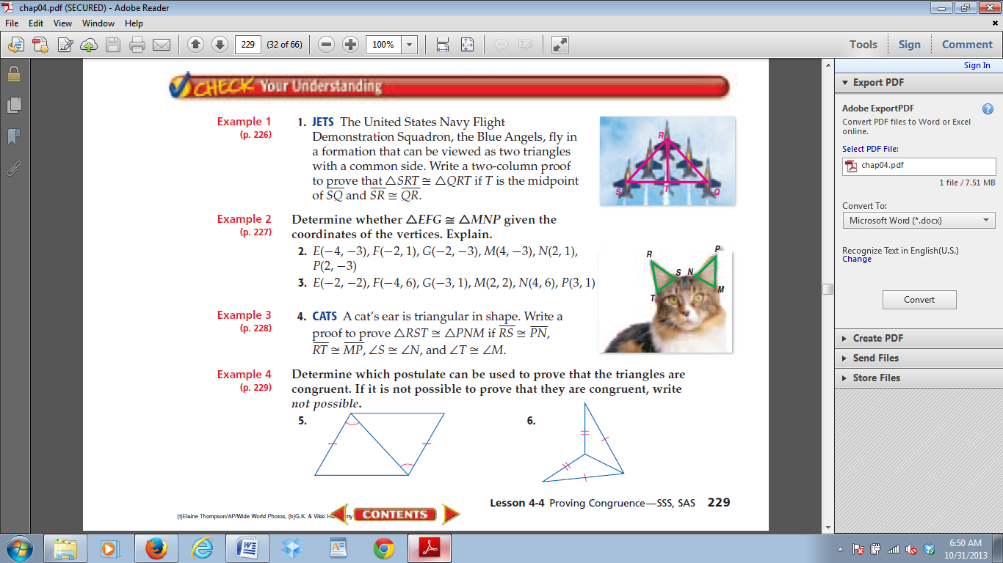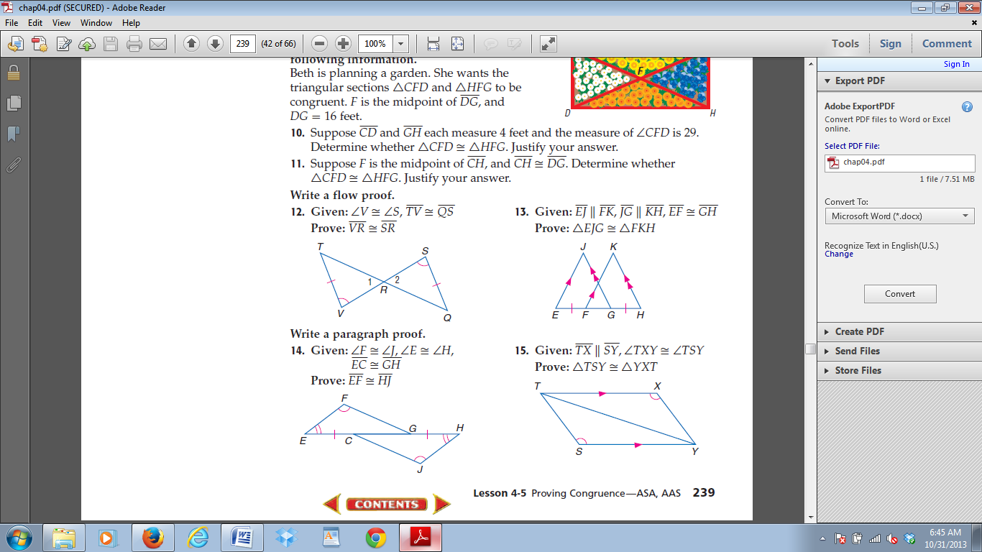d. ______________ e. ______________ f. _____________

