PROOFS USING CONGRUENT TRIANGLES Name __________________ 2nd 3rd 4th

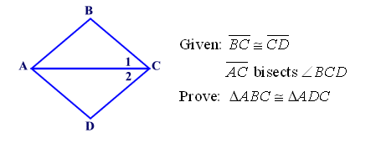1.

2. Given: 

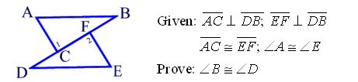

3.

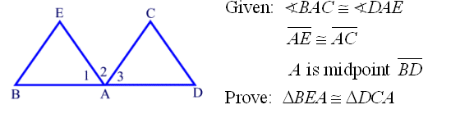4.

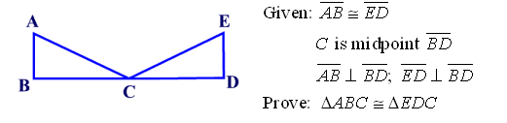5.

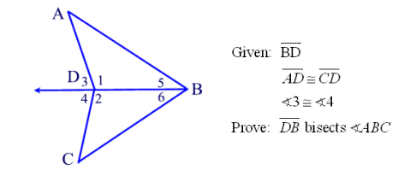6.

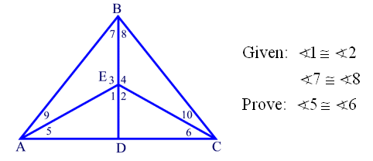7.