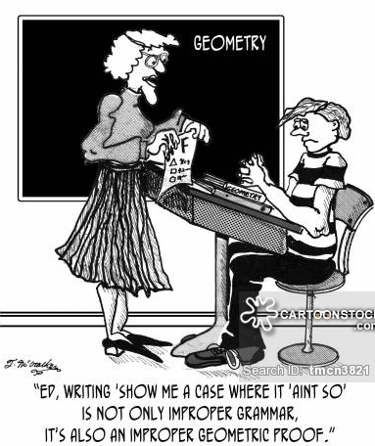
From Ask Dr. Math:

A proof is just an orderly way to show that something is true, by building on other things you know are true. The only way that order matters is that each thing you say must be based on something you've already said. Often it will be based on the previous statement, but sometimes you will have to use earlier statements as well. Think of it as building a tower to reach a high goal. Your "givens" are the foundation someone laid for you, and the theorems you have are the girders and rivets you have to put together to make the tower. Let's try drawing your sample
proof as a building, to show how its parts are connected...
From SparkNotes:
Writing a proof consists of a few different steps.
- Draw the figure that illustrates what is to be proved. The figure may already be drawn for you, or you may have to draw it yourself.
- List the given statements, and then list the conclusion to be proved. Now you have a beginning and an end to the proof.
- Mark the figure according to what you can deduce about it from the information given. This is the step of the proof in which you actually find out how the proof is to be made, and whether or not you are able to prove what is asked. Congruent sides, angles, etc. should all be marked so that you can see for yourself what must be written in the proof to convince the reader that you are right in your conclusion.
- Write the steps down carefully, without skipping even the simplest one. Some of the first steps are often the given statements (but not always), and the last step is the conclusion that you set out to prove.

