# Proving Congruence Name____________________

State which theorem can be used to prove the triangles congruent. Write a congruence statement. If the triangles cannot be proved congruent, write not possible and do not include a congruence statement.

NOTE: Never assume sides or angles are congruent unless they are marked as congruent.

K

J

I

H

G

A

B

C

E

F

D

1. 2. 3.

K

N

M

L

________________ ________________ ________________

≅ Stmt: _________________ ≅ Stmt: _________________ ≅ Stmt: _________________

P

N

R

O

S

W

U

T

4. 5. 6.

X

Y

Z

R

________________ ________________ ________________

≅ Stmt: _________________ ≅ Stmt: _________________ ≅ Stmt: _________________

A

B

D

C

I

K

L

J

7. 8. 9.

E

F

G

H

X

W

V

________________ ________________ ________________

≅ Stmt: _________________ ≅ Stmt: _________________ ≅ Stmt: _________________

For #10-11, what additional information would you need to prove the triangles congruent by HL?

A

E

D

C

B

10. 11. In ΔFGH and ΔIJK,  ≅  and  ≅ .

J

I

K

F

G

H

For #12-13, draw and label the congruent triangles.

X

W

V

12. If:

ΔLMN ≅ ΔOPR

m∠L = 29

m∠P = 66

m∠N = (4x + 53)

Find:

x and m∠R

13. If:

ΔLMN ≅ ΔOPR

LM is 10 less than 3 times number n

LN is 2 less than twice the number n

PR is 5 more than the number

OP is 4 more than the number n

Find:

LN and OR

For #14-17, draw a picture for each problem and then answer each question.

14. In isosceles ΔABC where AB ≅ CB and D is the midpoint of AC, then ΔABD ≅ ΔCBD by:

a. HL b. SSS c. SAS d. either SSS, SAS or HL

15. In ΔABC and ΔRST, m∠A = 82, m∠S = 76, m∠C = 22, ∠A ≅ ∠R and AC ≅ RT.

The two triangles are congruent by:

a. AAA b. ASA or AAS c. SSA d. not enough information

16. To prove two triangles congruent by HL, what additional information must be known?

C

B

A

T

S

R

a. ∠A ≅ ∠R b. ∠T ≅ ∠A c. AB ≅ BC

d. ∠ABC and ∠RST are right angles

17. For what values of x and y will the triangles be congruent? By what postulate can it be proven?

Show all work

2x – y

10

-5x + y

5

x = ____________

y = ____________

Postulate: _______

For #18-19, complete each congruence statement and the postulate or theorem that applies.

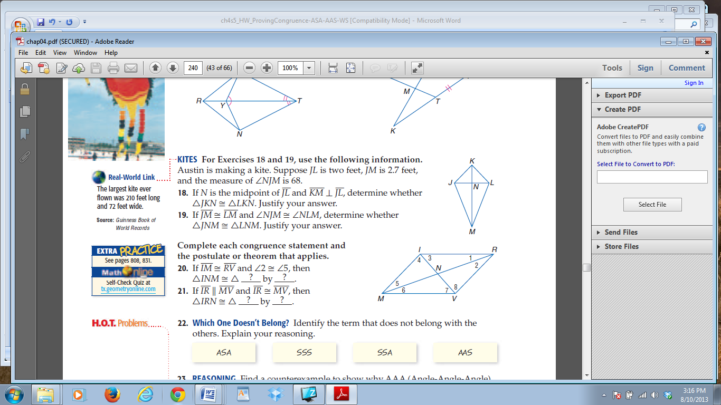18. If IM ≅ RV and ∠2 ≅∠5, then ΔINM ≅ Δ_____ by __________

19. If IR || MV and IR ≅ MV, then ΔIRN ≅ Δ_____ by __________

20. Draw and label two triangles that could be proven congruent by SAS.

21. Draw and label two triangles with the same 2 side measures (SS) and nonincluded angle measure (A)

 that could be used to show why SSA can not be used to prove triangle congruence.