Quadrilateral: Some Practice Problems BERNHARD GT GEOMETRY Name _________________________

Check all that apply

|  |  |  |  |  |  |  |  |
| --- | --- | --- | --- | --- | --- | --- | --- |
|  | Parallelogram | Rectangle | Rhombus | Square | Kite | Trapezoid | Isosceles  Trapezoid |
| opposite sides are parallel |  |  |  |  |  |  |  |
| opposite sides are congruent |  |  |  |  |  |  |  |
| opposite angles are congruent |  |  |  |  |  |  |  |
| all 4 sides are congruent |  |  |  |  |  |  |  |
| all 4 angles are right angles |  |  |  |  |  |  |  |
| the diagonals bisect each other |  |  |  |  |  |  |  |
| the diagonals are perpendicular |  |  |  |  |  |  |  |
| the diagonals are congruent |  |  |  |  |  |  |  |
| the diagonals bisect opposite angles |  |  |  |  |  |  |  |

1. Given Rectangle ABCD. If , and , find and .

2. Given Square HIJK with diagonals intersecting at L. If , find each of the following:

a) HL b) IK c)  d)  e) Perimeter of 

3. Given Rhombus WXYZ , . Find 

4. Given Rectangle WXYZ and Triangle XYZ. Triangle XYZ has a perimeter of 24 units.

Find WY if 

5. Answer each of the following with AT (always true), ST (sometimes true) or NT (never true).

_______ a. A rhombus is a parallelogram.

_______ b. A rectangle is a square.

_______ c. A parallelogram has exactly one right angle.

_______ d. The diagonals of a rhombus are perpendicular.

6. In quadrilateral MATH, MT and AH bisect each other at R and MR ≅ HR. MATH must be a

I. parallelogram

II. rectangle

III. square

A. I only B. II only C. I and II D. II and III E. I, II and III

7. Coordinate Proof Find the missing coordinates for Rhombus PQRS.





Prove the diagonals of a rhombus are perpendicular using a COORDINATE PROOF.



8. Given: Rhombus ABCD

Find x and y

9. For a regular nonagon, find:

Sum of the interior angles________________ Measure of each interior angle______________

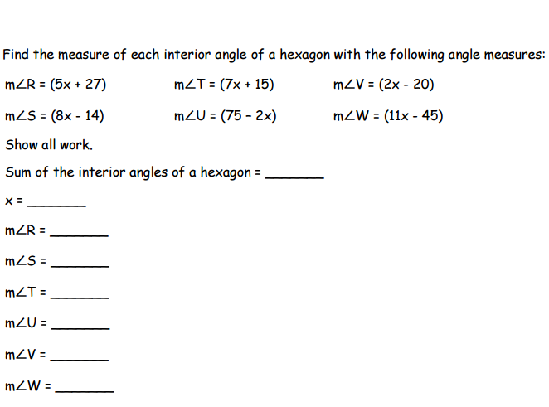Measure of each exterior angle____________ Sum of the exterior angles.

10.

C 52

**E3x**

D B

A

A 4x + 10

Kite ABCD Segment EF is a midsegment of Trapezoid ABCD

X= ____________ y=_______________ x=_______________