BERNHARD – GT GEOMETRY Practice Problems 1.1-1.4 Name _______________________

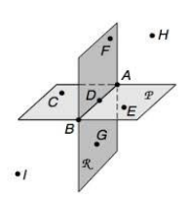

1. Plane *P* and Plane *K* intersect at _________________.
2. True of False: Points F, A and E are coplanar.
3. Name a line that in contained in Plane *P.*

*____________________*

1.  and _______________ are skew lines.
2. Name 3 collinear points. ____________________________.

1. 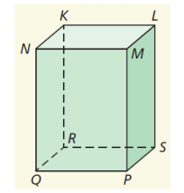 Name a point that is coplanar to points R, P and Q. _________________
2. List the planes that contain :
3.  and  intersect at ____________________.
4. Name a ray that contains Point N.

Sketch each of the following:

1. Line *m* intersects PlaneABC at point B.
2. Ray XY.

c)_ Skew lines AB and CD.

Solve for each variable.

If point P is between points A and B, find the value of each variable.

a)

b)

If P is the midpoint of segment AB, find the value of each variable.

a)

b)