For #1-7, determine which of the following pairs of triangles are similar. If they are similar, state the similarity rule (AA~, SSS~, SAS~). Figures are not drawn to scale.

12

18

12

8

20

30

6

6

4

8

62°

74°

62°

44°

1. 2. 3.

Similar? No/Yes Similar? No/Yes Similar? No/Yes

15

12

4

5

25°

25°

21

6

4. 5.

6

8

12

16

Similar? No/Yes Similar? No/Yes

4

6

2

6

9

3

80°

80°

6. 7.

Similar? No/Yes Similar? No/Yes

For # 8-11, find x and the measures of the indicated sides. Show all work.

8. 9. AD = 12. Perimeter of ΔAEB = 12.

C

F

A

B

E

2

5

x2 +==+2++222422

10

x + 3

12

9

A

B

C

D

E

x = ________ x = ________

AB = ________ AB = ________

AC = ________ AC = ________ Perimeter of ΔADC = ________

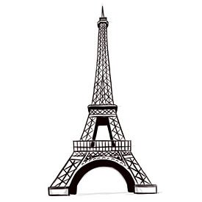

10. A replica of the Eiffel Tower at an amusement park is 350 2/3 feet tall. The actual Eiffel Tower is 1052 feet tall. What is the scale factor comparing the amusement park tower to the actual tower? Label the drawings of the two towers.

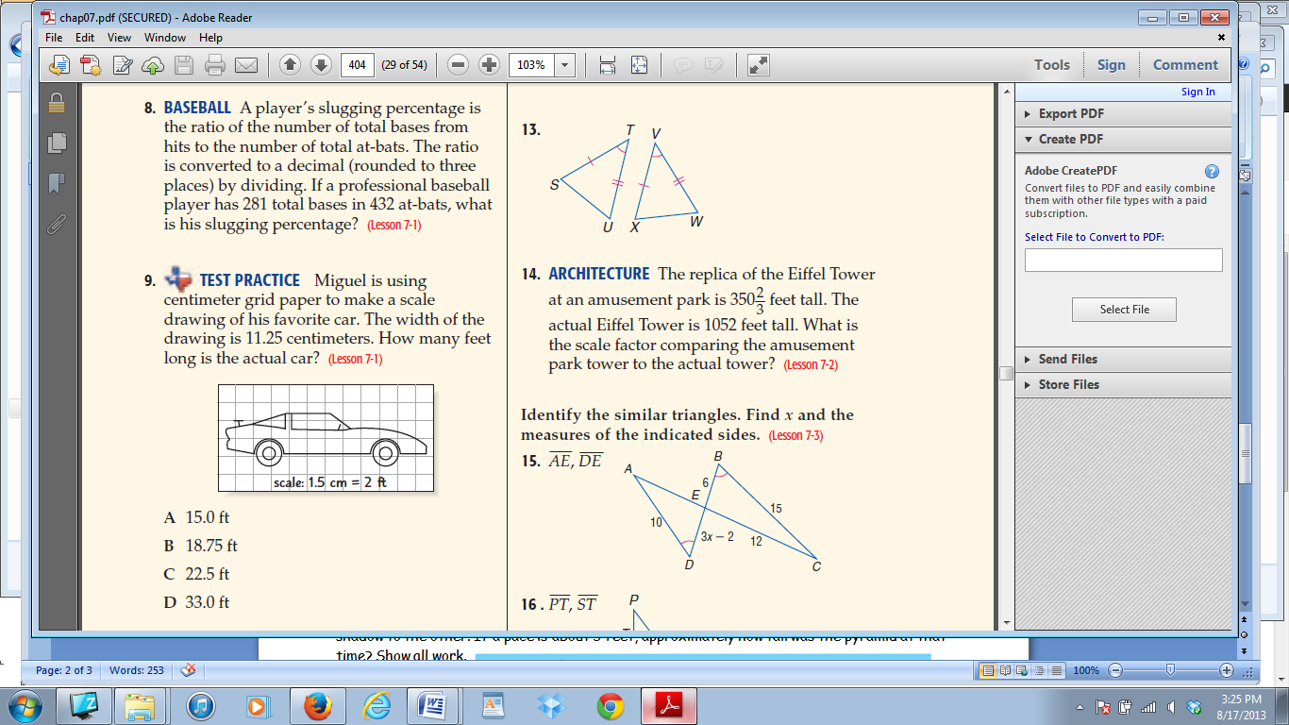11. Miguel is using centimeter grid paper to make a scale drawing of his favorite car. The width of the drawing is 11.25 centimeters. How many feet long is the actual car?

12. Which pairs of polygons are similar? STATE REASON.

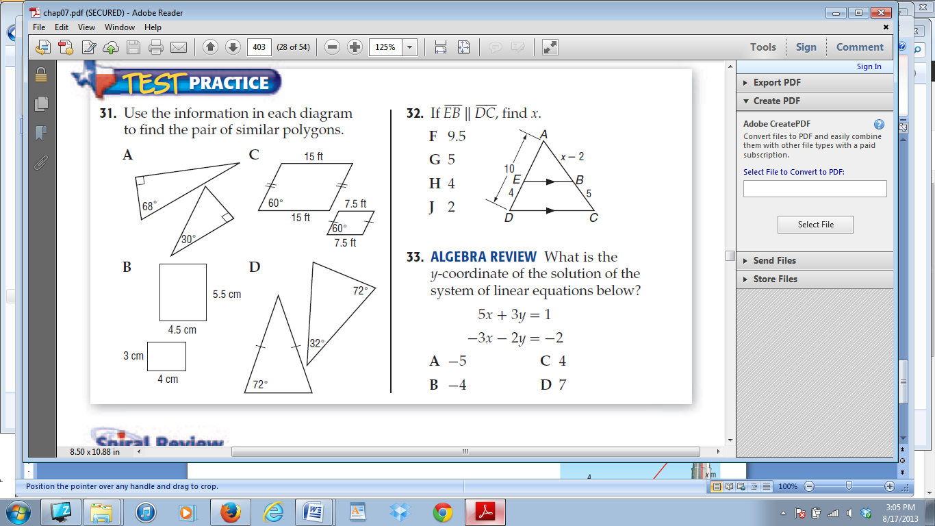

Show all work.

16 ft

8 ft

Yes/No Yes/No Yes/No Yes/No



p. 412 SHOW ALL WORK!!

26) & 27)

|  |  |  |  |  |
| --- | --- | --- | --- | --- |
| 32) | 33) | 34) | 35) | 36) |