The Sierpinski Carpet Fractal
You will need graph paper to complete this or you may use this website
http://www.shodor.org/interactivate/activities/SierpinskiCarpet/
BERNHARD GT GEOMETRY
Name ______________________
Date ____________ Period_____
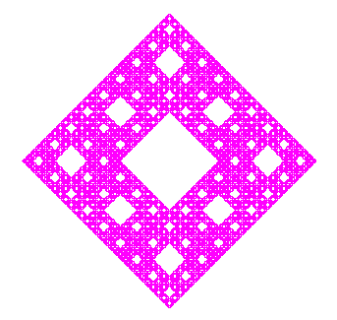
Here are the steps that you will need to follow in order to draw each level of the Sierpinski Carpet.
This fractal will be completed using the “method of successive removals” method.
Level 1.
On grid paper (100 units by 100 units), draw a square that has a length of 81 units and a width of 81 units. Shade in the entire square. Find the perimeter area. On the table below, fill in the perimeter and area.
Level 2.
On another piece of grid paper, draw a square that has the same outline as in level 1 (81 units by 81 units). Think of the square that you have drawn as a square that is made up of 9 smaller squares (27 units by 27 units). Now, shade in all the squares but the middle square. This is the square that we have “removed.” On the table below, fill in the perimeter and area.
Level 3.
Redraw the same object that you had in level 2. There are 8 squares that were shaded. Divide each square into 9 smaller squares (9 units by 9 units). Shade in all parts of these squares except the middle square. On the table below, fill in the area and perimeter.

Level | Length of each side | Perimeter | Total Area | Area Removed
1
2
3
4
5
n
As the number of levels approaches infinity, we can see that the perimeter also is infinite.
The total remaining area equals zero since the amount removed equals also equals A:
Total Remaining Area =
Initial Area – Total Area Removed =

