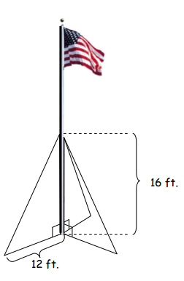
Special Right Triangle Practice Problems NO CALCULATOR!!! Name _______________________

- The perimeter of an equilateral triangle is 33 m. Find its area.

- The diagonal of a square is inches. Find its perimeter.

- Solve for each variable.

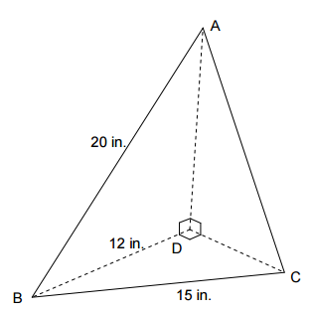
- Three right triangles are joined at their right angle vertices to form a triangular pyramid. What is the length of AC?

- A flag is attached to the top of a 30 foot pole similar to the one shown. Three wires are attached to the pole 16 feet above the ground and are anchored to the ground 12 feet from the base. How many total feet of wire are needed to secure the flag pole?

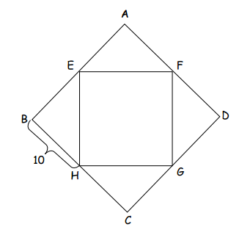
- Square EFGH was created by connecting the midpoints of the sides of Square ABCD.
- What is the perimeter of EFGH?

- What is the length of each diagonal of ABCD?

- What is the length of each diagonal of EFGH?

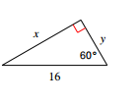
- Find the value of each variable.
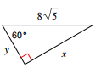
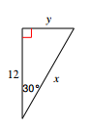

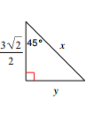

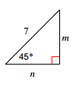

- Two poles are 40 feet high and 46 feet high. They are 9 feet apart. How long is a wire stretched from the top of one pole to the top of the other?

- Can a stick 24 inches long be laid in the bottom of a box 20 inches by 16 inches?

