**Unit 1 Practice** **Problems**  Name ____________

1. Find the measure of each angle:

a) Two angles form a linear pair. The measure of one angle is  the measure of the other angle.

1. The measure of angle is the measure of its complement.
2.  when  is a straight angle with P in its interior.
3. The sum of the measure of two complementary angle is 74 degrees greater than the difference of their measure. Find the measure of each angle.
4. Determine whether the statement is AT, ST or NT.
5. 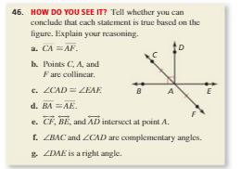 An integer is a whole number
6. An irrational number if a real number
7. A rational number is an integer
8. A whole number is a rational number
9. An integer is an irrational number
10. A whole number is negative
11. A natural number is an integer
12. An irrational number is negative