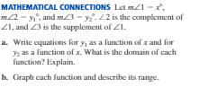**Unit 1 Practice** **Problems**  Name ____________

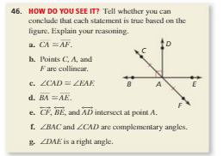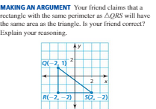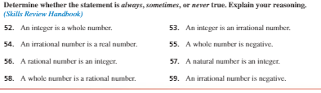****

Find the measure of each angle:

1. Two angles form a linear pair. The measure of one angle is  the measure of the other angle.
2. The measure of angle is the measure of its complement.
3.  when  is a straight angle with P in its interior.